DOCUMENT 28 — A/B Testing & Experimentation Framework
Visionary Internal · v1.0 · R5: A/B everything, kill what underperforms

Experiments change teaching behavior, so every experiment carries safety guardrails
and a pre-registered kill rule. Pedagogy is product surface, not opinion.

1. Mechanics
- Unit of diversion: student_id hash; stratified by board/class/language/device_tier.
- Global holdout 5% (never exposed to experimental pedagogy) for long-run effect.
- Primary metric pre-registered: ΔP(mastered) or task-success; guardrails: safety flags,
TTFT, hallucination rate, complaint rate — any guardrail breach auto-stops the arm.
- Sequential testing with early-stop; minimum detectable effect set pre-launch.
- Feature flags separate deploy from release; kill switch per flag.

2. Lifecycle
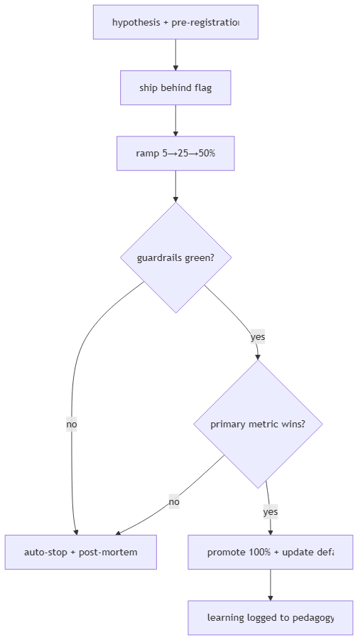

3. Rules
- No experiment on crisis/safety paths or consent flows.
- Minors: never test pricing or dark-pattern-adjacent copy (none exist anyway).
- Weekly experiment council: PM + ML-lead + SME review kills/promotions.

OKF
KF1 100% pedagogy changes ship as experiments · KF2 guardrail breach stops arm ≤1h ·
KF3 holdout maintained ≥1 quarter · KF4 every promotion writes pedagogy-efficacy row ·
KF5 zero unflagged teaching-behavior deploys.

